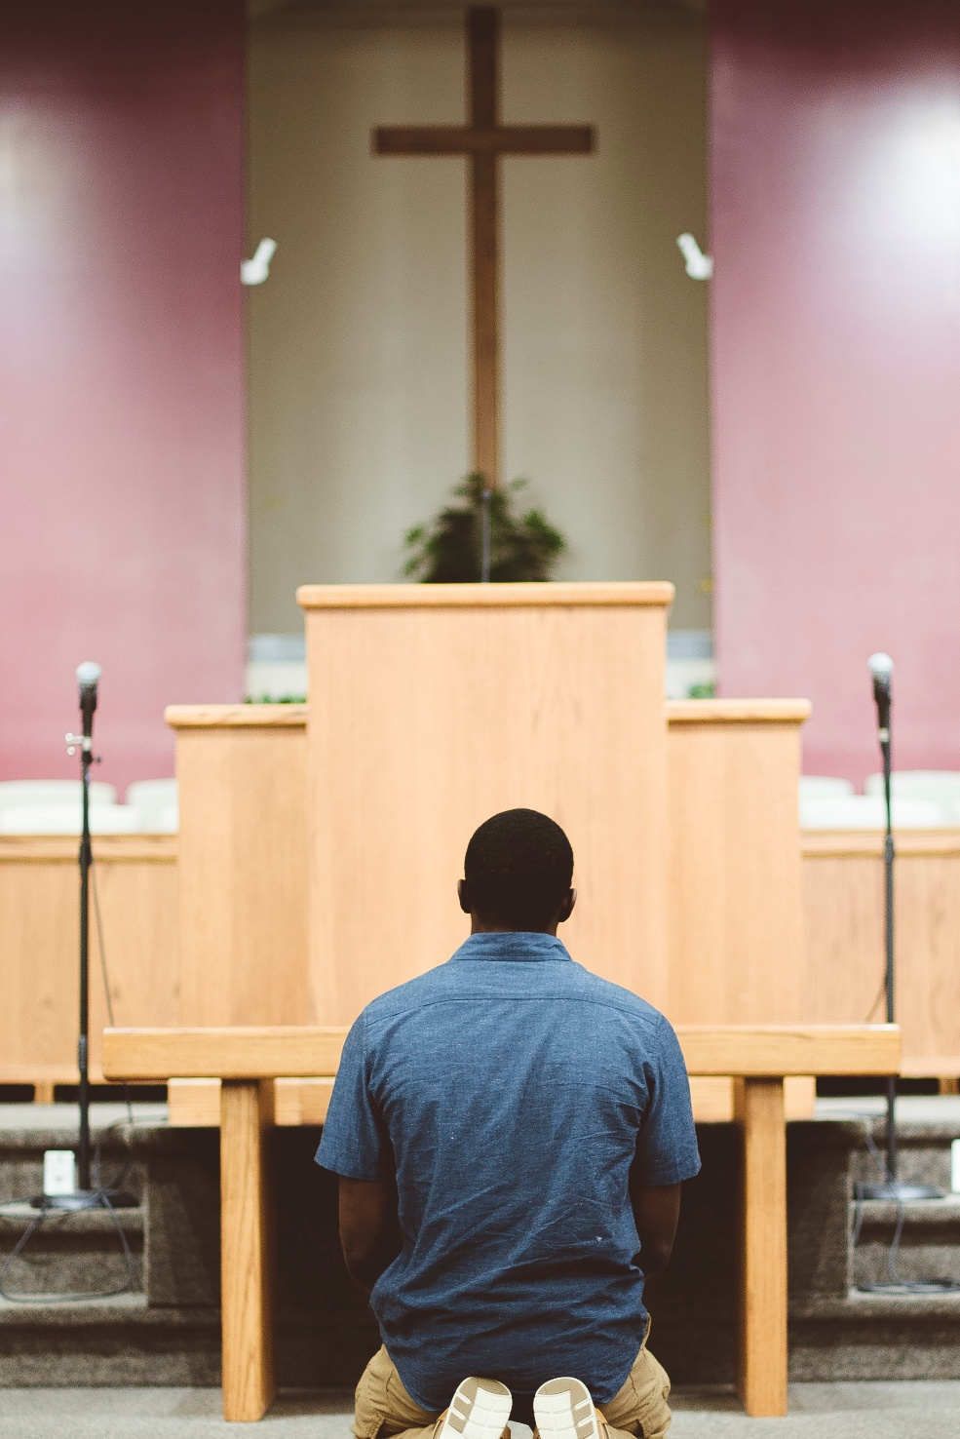

Vocations Sunday
Date
Church name
"Our vocation is not simply to be, but to work together with God in the creation of our own life, our own identity, our own destiny." — Thomas Merton

A hymn may be sung
The president may say:

Blessed be God, Father, Son and Holy Spirit,
Blessed be God’s Kingdom now and for ever.
The Grace of our Lord Jesus Christ, the love of God and the Fellowship of the Holy Spirit be always with you. And also with you.

The president greets the people:
On this Vocations Sunday we give thanks to God that you call us all to
varieties of forms of service in God’s Church and in the world. And so we pray
for openness to the Holy Spirit, that each of us may discern the call of God
upon our lives.

Let us pray,
Almighty God,
to whom all hearts are open,
all desires known,
and from whom no secrets are hidden:
cleanse the thoughts of our hearts
by the inspiration of your Holy Spirit,
that we may perfectly love you,
and worthily magnify your holy name;
through Christ our Lord.
Amen.

A minister says:
‘I set no store by life:
I only want to finish the race and complete the task
that the Lord has assigned to me,
of bearing witness to the gospel of God’s grace.’
Let us confess our failure to live up to our calling.
Lord Jesus, you said to your disciples:
‘You have not chosen me, but I have chosen you.’
Lord, have mercy.
Lord, have mercy.

Lord Jesus, we know that the harvest is plentiful
but the labourers are few.
Christ, have mercy.
Christ, have mercy.
Lord Jesus, you appointed us to go and bear fruit that will last.
Lord, have mercy.
Lord, have mercy.

A minister says:
God of the spirit of kindness,
in the gory of earth and sea and stars,
in the kaleidoscope of colour and share and shapeliness,
in the patters of humour and tenderness and touch,
we celebrate your generosity.
Forgive us when we forget the gift in our every breath,
the care that sustains our every moment,
the grace that can transform our every day.
Set us free from the prison of grudging hearts,
mean desires,
resentful spirits,
give us the courage to act with justice and generosity,
and draw us into love that does not calculate or keep scores. Pattern of our Days
We turn to you, O God;
we renounce evil;
we claim your love;
we choose to be made whole.

The presiding priest says
God forgives you.
Forgive others;
Forgive yourself.

Glory to God in the highest,
and peace to God’s people on earth.
Lord God, heavenly King,
almighty God and Father,
we worship you, we give you thanks,
we praise you for your glory.
Lord Jesus Christ, only Son of the Father,
Lord God, Lamb of God,
you take away the sin of the world:
have mercy on us;
you are seated at the right hand of the Father:
receive our prayer.
For you alone are the Holy One,
you alone are the Lord,
you alone are the Most High, Jesus Christ,
with the Holy Spirit,
in the glory of God the Father. Amen.

The Collect
Let us pray for the ministry of the whole people of God.

Almighty God,
by whose Spirit the whole body of your Church
is called into a royal priesthood,
hear our prayer for all members of your Church
that in their vocation and ministry
they may truly serve you,
devoutly love you
and faithfully follow in the way of your Son,
Jesus Christ our Lord. Amen.

God our Shepherd,
in every generation you call
ministers of your word and sacraments.
Equip them to preach the gospel,
to care for your people
and to show forth the fruit of the Spirit in their lives;
in the name of Jesus our Saviour. Amen.

One or two readings from below or use some of the suggested ones from the leadership team.

First Reading – 1 Samuel 3.1-10

Now the boy Samuel was ministering to the Lord under Eli. The word of the Lord was rare in those days; visions were not widespread. At that time Eli, whose eyesight had begun to grow dim so that he could not see, was lying down in his room; the lamp of God had not yet gone out, and Samuel was lying down in the temple of the Lord, where the ark of God was. Then the Lord called, ‘Samuel! Samuel!’* and he said, ‘Here I am!’ and ran to Eli, and said, ‘Here I am, for you called me.’ But he said, ‘I did not call; lie down again.’ So he went and lay down. The Lord called again, ‘Samuel!’ Samuel got up and went to Eli, and said, ‘Here I am, for you called me.’ But he said, ‘I did not call, my son; lie down again.’ Now Samuel did not yet know the Lord, and the word of the Lord had not yet been revealed to him. The Lord called Samuel again, a third time. And he got up and went to Eli, and said, ‘Here I am, for you called me.’ Then Eli perceived that the Lord was calling the boy. Therefore Eli said to Samuel, ‘Go, lie down; and if he calls you, you shall say, “Speak, Lord, for your servant is listening.” ’ So Samuel went and lay down in his place.
Now the Lord came and stood there, calling as before, ‘Samuel! Samuel!’ And Samuel said, ‘Speak, for your servant is listening.’
Hear the word of the Lord.
Thanks be to God.

Psalm 19
The heavens are telling the glory of God;
and the firmament proclaims his handiwork.
Day to day pours forth speech,
and night to night declares knowledge.
There is no speech, nor are there words;
their voice is not heard;
yet their voice goes out through all the earth,
and their words to the end of the world.
In the heavens he has set a tent for the sun,
which comes out like a bridegroom from his wedding canopy,
and like a strong man runs its course with joy.
Its rising is from the end of the heavens,
and its circuit to the end of them;
and nothing is hidden from its heat.
The law of the Lord is perfect,
reviving the soul;
the decrees of the Lord are sure,
making wise the simple;
the precepts of the Lord are right,
rejoicing the heart;
the commandment of the Lord is clear,
enlightening the eyes;
the fear of the Lord is pure,
enduring for ever;
the ordinances of the Lord are true
and righteous altogether.
More to be desired are they than gold,
even much fine gold;
sweeter also than honey,
and drippings of the honeycomb.
Moreover by them is your servant warned;
in keeping them there is great reward.
But who can detect their errors?
Clear me from hidden faults.
Keep back your servant also from the insolent;
do not let them have dominion over me.
Then I shall be blameless,
and innocent of great transgression.
Let the words of my mouth and the meditation of my heart
be acceptable to you,
O Lord, my rock and my redeemer.

Second Reading – Ephesians 4.1-6
I therefore, the prisoner in the Lord, beg you to lead a life worthy of the calling to which you have been called, ²with all humility and gentleness, with patience, bearing with one another in love, ³making every effort to maintain the unity of the Spirit in the bond of peace. ⁴There is one body and one Spirit, just as you were called to the one hope of your calling, ⁵one Lord, one faith, one baptism, ⁶one God and Father of all, who is above all and through all and in all.

This is the word of the Lord. Thanks be to God.

A hymn or song may be sung

The Lord be with you.
And also with you.
Hear the Gospel of our Lord Jesus Christ according to John, chapter fifteen, beginning at the twelfth verse.
Glory to you, Lord Jesus Christ.
‘This is my commandment, that you love one another as I have loved you. No one has greater love than this, to lay down one’s life for one’s friends. You are my friends if you do what I command you. I do not call you servants* any longer, because the servant does not know what the master is doing; but I have called you friends, because I have made known to you everything that I have heard from my Father. You did not choose me but I chose you. And I appointed you to go and bear fruit, fruit that will last, so that the Father will give you whatever you ask him in my name. I am giving you these commands so that you may love one another.

This is the Gospel of the Lord. Praise to you, Lord Jesus Christ.

Sermon

The president says:
Let us declare our faith in God, Father, Son and Holy Spirit.
We believe in one God,
the Father, the Almighty,
maker of heaven and earth,
of all that is,
seen and unseen.
We believe in one Lord, Jesus Christ,
the only Son of God,
eternally begotten of the Father,
God from God, Light from Light,
true God from true God,
begotten, not made,
of one Being with the Father.
Through him all things were made.
For us and for our salvation he came down from heaven,
was incarnate from the Holy Spirit and the Virgin Mary,
and was made truly human.
For our sake he was crucified under Pontius Pilate;
he suffered death and was buried.
On the third day he rose again
in accordance with the Scriptures;
he ascended into heaven
and is seated at the right hand of the Father.
He will come again in glory to judge the living and the dead,
and his kingdom will have no end.
We believe in the Holy Spirit,
the Lord, the giver of life,
who proceeds from the Father and the Son.
With the Father and the Son he is worshipped and glorified.
He has spoken through the prophets.
We believe in one holy, catholic and apostolic Church.
We acknowledge one baptism for the forgiveness of sins.
We look for the resurrection of the dead,
and the life of the world to come. Amen.

Prayers of the People
Lord God of all,
over all and in all and through all:
we give thanks that we are called to your service;
may all your people be attentive and obedient to your calling.
Lord, hear your people
and answer our prayers.

Lord of all, we give thanks that you call some to be apostles, sent out to do your work.
We pray for all who respond to this calling to serve in your name:
for those immersed in the world, seeking to bear witness to the gospel in word and action,
for those whose service takes them to places where they face opposition and difficulty,
may they be continually filled with your Spirit, and empowered to follow your calling.
Lord, hear your people
and answer our prayers.

Lord of all, we give thanks that you call some to be prophets.
We pray for all whom you have called to speak out and proclaim the values of your kingdom:
for those who challenge injustice and apathy and untruth,
for those who campaign for the well-being of your people and your world,
may they be continually filled with your vision, and have courage in their prophetic calling.
Lord, hear your people
and answer our prayers.

Lord of all, we give thanks that you call some to be evangelists.
We pray for all whom you have called to share the message of your love:
for those who communicate the good news of Christ to others from a variety of backgrounds,
for those whose enthusiasm and love conveys your truth,
may they be filled with your love as they share the good news with others.
Lord, hear your people
and answer our prayers.

Lord of all, we give thanks that you call some to be pastors.
We pray for all whom you have called to care for others through prayer and through service:
for those who take care of any who are young or old, who are sick or struggling,
for those whose work supports medical, social and community services,
may their lives be channels of your love and grace.
Lord, hear your people
and answer our prayers.

Lord of all, we give thanks that you call some to be teachers.
We pray for all whom you have called to encourage adults and children to learn and grow:
for those who teach informally as parents, mentors and facilitators,
for workers in schools, colleges and universities, and for those who teach in our churches,
may they speak your truth, and help others to grow in wisdom.
Lord, hear your people
and answer our prayers.

God of peace,
let us your people know,
that at the heart of turbulence
there is an inner calm that comes
from faith in you.
Keep us from being content with things as they are,
that from this central peace
there may come a creative compassion,
a thirst for justice,
and a willingness to give of ourselves
in the spirit of Christ.
Amen.

The priest says

Grace to you and peace
from God our Creator,
the love at our beginning
and without end,
in our midst and with us.
God is with us,
here we find new life.

The peace of the Lord be always with you.
And also with you.

Let us offer one another a sign of peace.
All may exchange a sign of peace.

A hymn or song/s may be sung
The gifts of the people may be gathered and presented.
This prayer may be said:

Heavenly Father,
as we set before you these gifts of bread and wine,
bless also the gift of our hearts and minds
as we offer our lives in your service;
for Jesus Christ’s sake.
Amen.

The Lord be with you.
And also with you.
Lift up your hearts.
We lift them to the Lord.
Let us give thanks to the Lord our God.
It is right to give thanks and praise.

It is indeed right,
it is our duty and our joy
at all times and in all places
to give you thanks and praise,
heavenly Father, source of all that is,
for you have called our world into existence,
and filled it with abundant life.
You called a chosen people as your own,
and led them in the way of holiness.
You called your beloved Son,
in whom you were well pleased,
to give his life for us on the cross,
and rise again in glory.
And now we give you thanks
that you call men and women
to equip your holy people for the work of ministry,
for the building up of the body of Christ.
Therefore with angels and archangels,
and with all the company of heaven,
we proclaim your great and glorious name,
for ever praising you and saying:
Holy, holy, holy Lord,
God of power and might,
heaven and earth are full of your glory.
Hosanna in the highest.
Blessed is he who comes in the name of the Lord.
Hosanna in the highest.

We praise and bless you, loving Father,
through Jesus Christ, our Lord;
and as we obey his command,
send your Holy Spirit,
that broken bread and wine outpoured
may be for us the body and blood of your dear Son.

On the night before he died he had supper with his friends
and, taking bread, he praised you.
He broke the bread, gave it to them and said:
Take, eat; this is my body which is given for you;
do this in remembrance of me.

When supper was ended he took the cup of wine.
Again he praised you, gave it to them and said:
Drink this, all of you;
this is my blood of the new covenant,
which is shed for you and for many for the forgiveness of sins.
Do this, as often as you drink it, in remembrance of me.
So, Father, we remember all that Jesus did,
his sacrifice made once for all upon the cross.
Bringing before you the bread of life and cup of salvation,
we proclaim his death and resurrection
until he comes in glory.
Dying, you destroyed our death.
Rising, you restored our life.
Christ Jesus, come in glory.

Lord of all life,
help us to work together for that day
when your kingdom comes
and justice and mercy will be seen in all the earth.
Look with favour on your people,
gather us in your loving arms
and bring us with all the saints
to feast at your table in heaven.
Through Christ, and with Christ, and in Christ,
in the unity of the Holy Spirit,
all honour and glory are yours, O loving Father,
for ever and ever.
Amen.

As our Saviour taught us, so we pray:
Our Father in heaven,
hallowed be your name,
your kingdom come,
your will be done,
on earth as in heaven.
Give us today our daily bread.
Forgive us our sins
as we forgive those who sin against us.
Save us from the time of trial
and deliver us from evil.
For the kingdom, the power,
and the glory are yours
now and for ever.
Amen.

We break this bread to share in the body of Christ.
Though we are many, we are one body, because we all share in one bread.

The gifts of God for the people of God.
Jesus Christ is holy,
Jesus Christ is Lord,
to the glory of God the Father.

During the distribution hymns and anthems may be sung.
Silence is kept.

Giver of life and love,
we thank you that in this heavenly banquet
you invigorate and renew us.
Living in the unity of the Spirit
may we boldly use your gifts
to continue your work in the world.
Amen.

Through Christ, and with all your saints,
we offer ourselves
and our lives to your service.
Send us out in the power of your Spirit,
to stand with you in your world.
We ask this through Jesus Christ, the servant,
our friend and brother. Amen.

A hymn may be sung.
The president says:

As you have been fed at this table
go to feed the hungry.
As you have been set free
go to set free the imprisoned.
As you have received – give.
As you have heard – proclaim.
And the blessing which you have received
from the Father, Son and Holy Spirit
be always with you. Iona, Pattern of our Days
Amen.

A minister says
Go in the peace of Christ.
In the name of Christ. Amen.

Resources:
A New Zealand Prayer Book https://anglicanprayerbook.nz/456.html
The Church of England – Common Worship
The Anglican Church of Australia – A Prayer Book for Australia
The Pattern of our Days: Liturgies and Resources for Worship from the Iona Community

*Please insert relevant copyright number for your Ministry Unit.

