Sunday Morning Home Worship
1 This is the day that the Lord has made.
I will rejoice and be glad in it.
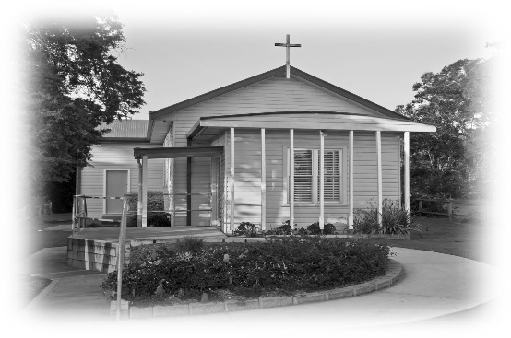
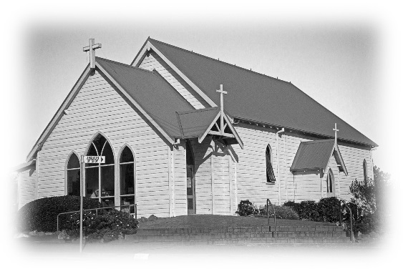
Psalm 118.24
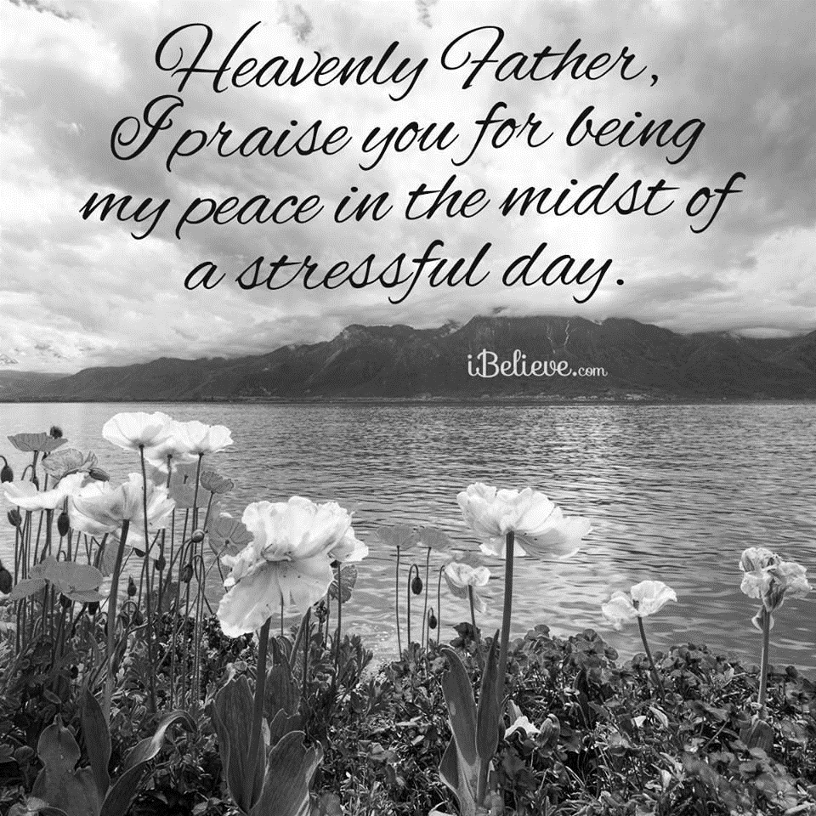
Sunday Morning Home Worship
Glory to God; Father, Son and Holy Spirit:
as in the beginning, so now, and for ever. Amen.

2 Read aloud the Opening Canticle:
O come, let us sing out to the Lord:
let us shout in triumph to the rock of our salvation.
Let us come before his face with thanksgiving:
and cry out to him joyfully in psalms.
For the Lord is a great God:
and a great king above all gods.
In his hand are the depths of the earth:
and the peaks of the mountains are his also.
The sea is his and he made it:
his hands moulded dry land.
Come, let us worship and bow down:
and kneel before the Lord our maker.
For he is the Lord our God:
we are his people and the sheep of his pasture.
Today if only you would hear his voice:
‘Do not harden your hearts as Israel did in the wilderness;
‘When your forebears tested me:
put me to proof though they had seen my works.
‘Forty years long I loathed that generation and said:
“It is a people who err in their hearts,
for they do not know my ways”;
‘Of whom I swore in my wrath:
“They shall not enter my rest.”’

3 Now pray this Opening Prayer:
I rejoice in the gift of this new day,
may the light of your presence, O God,
set my heart on fire with love for you;
now and for ever. Amen.

Pause for a moment of self-examination,
and then pray this Confession:

Merciful God,
our maker and our judge,
I have sinned against you in thought, word, and deed,
and in what I have failed to do:
I have not loved you with my whole heart;
I have not loved my neighbours as myself;
I repent, and am sorry for all my sins.
Father, forgive me.
Strengthen me to love and obey you in newness of life;
through Jesus Christ my Lord. Amen.

After a moment of reflection, read these Words of Assurance:
1 John 1.9 tells us that, ‘If we confess our sins, God who is faithful and just will forgive us our sins and cleanse us from all unrighteousness.’

4 Psalm

5 After the Psalm pray this short prayer:
Lord God, whose blessed Son rose in triumph and set us free: grant me the fullness of life he promised, that through the Holy Spirit my heart may possess him whom my eyes cannot see, the same Jesus Christ my Lord. Amen.

6 Bible Reading

6a Reflection on reading

7 Say aloud The Canticle (The Song of Zechariah) - Luke 1.68–79
Blessed be the Lord, the God of Israel:
who has come to his people and set them free.
The Lord has raised up for us a mighty Saviour:
born of the house of his servant David.
Through the holy prophets, God promised of old:
to save us from our enemies, from the hands of
all who hate us,
To show mercy to our forebears:
and to remember his holy covenant.
This was the oath God swore to our father Abraham:
to set us free from the hands of our enemies,
Free to worship him without fear:
holy and righteous before him, all the days of our life.
And you, child, shall be called the prophet of the Most High:
for you will go before the Lord to prepare his way,
To give his people knowledge of salvation:
by the forgiveness of their sins.
In the tender compassion of our God:
the dawn from on high shall break upon us,
To shine on those who dwell in darkness
and the shadow of death:
and to guide our feet into the way of peace.
8 Say aloud The Apostles’ Creed:
I believe in God, the Father almighty,
creator of heaven and earth.
I believe in Jesus Christ, God’s only Son, our Lord,
who was conceived by the Holy Spirit,
born of the virgin Mary,
suffered under Pontius Pilate,
was crucified, died, and was buried;
he descended to the dead.
On the third day he rose from the dead;
he ascended into heaven,
and is seated at the right hand of the Father;
from there he will come to judge
the living and the dead.
I believe in the Holy Spirit,
the holy catholic Church,
the communion of saints,
the forgiveness of sins,
the resurrection of the body,
and the life everlasting. Amen.
9 The Prayers

Take some time to pray for whatever or whoever may be on your heart.
Prayers of the People – out loud or on the heart.
Pray the following prayer:
Loving God, source of healing and comfort,
at this time of fear, fill us with your grace,
that the sick may be made whole,
this virus contained and a cure found.
Strengthen those who care for the sick,
calm the anxious and protect the most vulnerable,
in the power of the Spirit
and in the faith of Jesus Christ our Lord.
Amen.
Pray the Lord’s Prayer:
Our Father in heaven,
hallowed be your name,
your kingdom come,
your will be done,
on earth as in heaven.
Give us today our daily bread.
Forgive us our sins
as we forgive those who sin against us.
Save us from the time of trial
and deliver us from evil.
For the kingdom, the power, and the glory are yours
now and for ever. Amen.

12 Finish by praying the Morning Collect:
Eternal God and Father, by whose power we are created and by whose love we are redeemed; guide and strengthen me by your Spirit, that I may give myself to your service, and live this day in love to others and to you; through Jesus Christ my Lord. Amen.

13 Receive my Blessing:
Grant, merciful Lord to your faithful children
pardon and peace,
that we may be cleansed from all sins
and serve you with a quiet mind;
through Jesus Christ our Lord.

Compiled by
Reverend Clyde

DAILY/WEEKLY AFFIRMATIONS
